1. Stadium Management

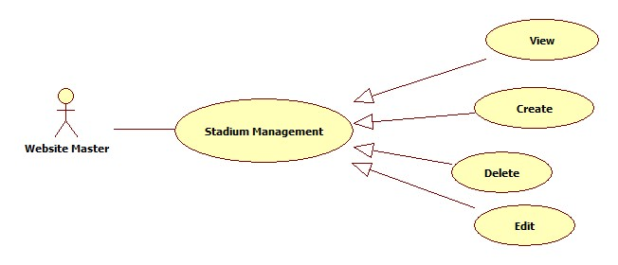

* 1. Stadium View Management

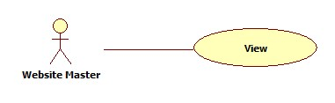

|  |  |  |  |  |
| --- | --- | --- | --- | --- |
| **USE CASE-n SPECIFICATION** | | | | |
| **Use-case No.** | <UC001> | **Use-case Version** | | <1.0> |
| **Use-case Name** | Stadium View Management | | | |
| **Author** | KhánhNQ | | | |
| **Date** | 12/02/2014 | **Priority** | High | |
| **Actor:**  Website Master  **Summary:**  This use case describe how to View all stadium in website  **Goal:**  View all Stadium in Website  **Triggers:**  Actor click on View button to view one of all stadium in website  **Preconditions:**  N/A  **Post-conditions:**    **Main Success Scenario:**   |  |  |  | | --- | --- | --- | | Step | Actor Action | System Response | | 1 | Click on name of Stadium to view | The system will show the new Stadium with the information |   **Alternative Scenario:**  N/A  **Exceptions:**  N/A  **Relationships:**  N/A  **Business Rules:**  N/A | | | | |

* 1. Stadium Create Management

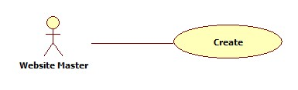

|  |  |  |  |  |
| --- | --- | --- | --- | --- |
| **USE CASE-n SPECIFICATION** | | | | |
| **Use-case No.** | <UC001> | **Use-case Version** | | <1.0> |
| **Use-case Name** | Stadium Management | | | |
| **Author** | KhánhNQ | | | |
| **Date** | 12/02/2014 | **Priority** | High | |
| **Actor:**  Website Master  **Summary:**  This use case describe how to Create stadium in website  **Goal:**  Create Stadium in Website  **Triggers:**  Actor click Create button Create stadium in website  **Preconditions:**  N/A  **Post-conditions:**    **Main Success Scenario:**   |  |  |  | | --- | --- | --- | | Step | Actor Action | System Response | | 1 | Click on Create to create a stadium | The system will respond to Create stadium page | | 2 | Enter information into text fields. Click on Create button to finish | The system will create new Stadium in database. |   **Alternative Scenario:**     |  |  | | --- | --- | | Actor Action | System Response | | Click on Cancel button to cancel | System will transfer to “Homepage” |   **Exceptions:**  N/A  **Relationships:**  N/A  **Business Rules:**  N/A | | | | |

* 1. Stadium Edit Management

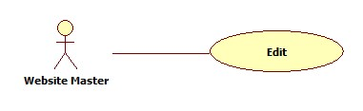

|  |  |  |  |  |
| --- | --- | --- | --- | --- |
| **USE CASE-n SPECIFICATION** | | | | |
| **Use-case No.** | <UC001> | **Use-case Version** | | <1.0> |
| **Use-case Name** | Stadium Edit Management | | | |
| **Author** | KhánhNQ | | | |
| **Date** | 12/02/2014 | **Priority** | High | |
| **Actor:**  Website Master  **Summary:**  This use case describe how to Edit with all stadium in website  **Goal:**  Edit all Stadium in Website  **Triggers:**  Actor click on Edit button to edit one of all stadium in website  **Preconditions:**  N/A  **Post-conditions:**    **Main Success Scenario:**   |  |  |  | | --- | --- | --- | | Step | Actor Action | System Response | | 1 | Click on Edit button to change Stadium Information | The system will show the Stadium with page of information was filled | | 2 | Click on field want to edit and change the last info |  | | 3 | Click on Save button to save information | The system will show the Stadium with page of new information |   **Alternative Scenario:**     |  |  | | --- | --- | | Actor Action | System Response | | Click on Cancel button to cancel | System will transfer to “Homepage” |   **Exceptions:**  N/A  **Relationships:**  N/A  **Business Rules:**  N/A | | | | |

* 1. Stadium Delete Management

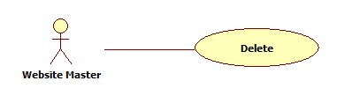

|  |  |  |  |  |
| --- | --- | --- | --- | --- |
| **USE CASE-n SPECIFICATION** | | | | |
| **Use-case No.** | <UC001> | **Use-case Version** | | <1.0> |
| **Use-case Name** | Stadium Delete Management | | | |
| **Author** | KhánhNQ | | | |
| **Date** | 12/02/2014 | **Priority** | High | |
| **Actor:**  Website Master  **Summary:**  This use case describe how to Delete stadium in website  **Goal:**  Delete one of all Stadium in Website  **Triggers:**  Actor click on Delete button to delete one of all stadium in website  **Preconditions:**  N/A  **Post-conditions:**    **Main Success Scenario:**   |  |  |  | | --- | --- | --- | | Step | Actor Action | System Response | | 1 | Click on Delete button to delete the stadium | The system will delete the stadium from the database |   **Alternative Scenario:**     |  |  | | --- | --- | | Actor Action | System Response | | Click on Cancel button to cancel | System will transfer to “Homepage” |   **Exceptions:**  N/A  **Relationships:**  N/A  **Business Rules:**  N/A | | | | |

1. User's Level System Management

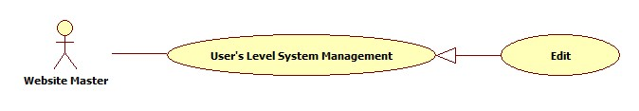

|  |  |  |  |  |
| --- | --- | --- | --- | --- |
| **USE CASE-n SPECIFICATION** | | | | |
| **Use-case No.** | <UC001> | **Use-case Version** | | <1.0> |
| **Use-case Name** | User's Level System Management | | | |
| **Author** | KhánhNQ | | | |
| **Date** | 12/02/2014 | **Priority** | High | |
| **Actor:**  Website Master  **Summary:**  This use case describe the level of user in this system, correlative with user ability  **Goal:**  Can set level to the user account  **Triggers:**  Actor use click on Edit button in page User Information.  **Preconditions:**  N/A  **Post-conditions:**    **Main Success Scenario:**   |  |  |  | | --- | --- | --- | | Step | Actor Action | System Response | | 1 | Click on Edit button in User Information | The system will show page of User Information | | 2 | Fill the level correlative with user ‘s point |  | | 3 | Click Save to save rank | The system will go back to page of User Information |   **Alternative Scenario:**   |  |  | | --- | --- | | Actor Action | System Response | | Click on Cancel button to cancel | System will go back to page of User Information |   **Exceptions:**  N/A  **Relationships:**  N/A  **Business Rules:**  N/A | | | | |